SPEAKER BIOS IEHA FALL CONFERENCE   | Kristina Box. MD, FACOG  State Health Commissioner  Dr. Box was named Indiana State Health Commissioner by Governor Eric J. Holcomb on September 18, 2017. She brings to the role a passion for improving the health of Hoosiers, beginning before birth.  Dr. Box has been a practicing obstetrician and gynecologist in Indianapolis for 30 years. She served on the Indiana Perinatal Quality Improvement Collaborative (IPQIC), an advisory council to the Indiana State Department of Health that is comprised of more than 300 statewide community professionals working to reduce infant mortality. Her work with IPQIC included serving on a state task force to address neonatal abstinence syndrome (NAS), which established standards for the diagnosis of NAS and developed a hospital study to determine the prevalence of drug exposed newborns.  Dr. Box earned her undergraduate degree at Indiana University in Bloomington and her medical doctorate at Indiana University School of Medicine in Indianapolis.  She and her husband of 40 years, David, a retired ophthalmologist, live in Indianapolis. They have four adult children and two grandchildren.  DR. BOX’S Keynote session will begin on Monday the 19th at 9:00 AM  “ Lessons Learned: Moving Public Health Forward in Indiana”
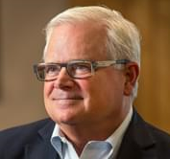 |  | William (Bill) Marler  An accomplished attorney and national expert in food safety, William (Bill) Marler has become the most prominent foodborne illness lawyer in America and a major force in food policy in the U.S. and around the world. Marler Clark, The Food Safety Law Firm, has represented thousands of individuals in claims against food companies whose contaminated products have caused life altering injury and even death.  Bill began litigating foodborne illness cases in 1993, when he represented Brianne Kiner, the most seriously injured survivor of the historic Jack in the Box E. coli O157:H7 outbreak, in her landmark $15.6 million settlement with the company. The 2011 book, Poisoned: The True Story of the Deadly E. coli Outbreak that Changed the Way Americans Eat, by best-selling author Jeff Benedict, chronicles the Jack in the Box outbreak and the rise of Bill Marler as a food safety attorney.  For the last 27 years, Bill has represented victims of nearly every large foodborne illness outbreak in the United States, filing lawsuits against such companies as Cargill, Chili’s, Chi-Chi’s, Chipotle, ConAgra, Dole, Excel, Golden Corral, KFC, McDonald’s, Odwalla, Peanut Corporation of America, Sheetz, Sizzler, Supervalu, Taco Bell and Wendy’s. Through his work, he has secured over $750,000,000 for victims of E. coli, Salmonella, and other foodborne illnesses.
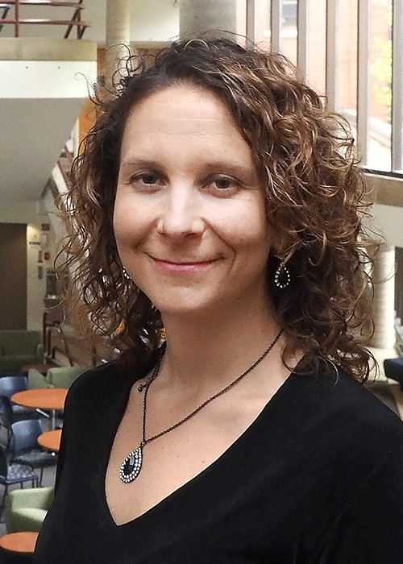 |  | Dr. Sara Heger  Dr. Heger is a researcher and instructor in the Onsite Sewage Treatment Program in the Water Resources Center at the University of Minnesota. Since 1999, she has been providing education and technical assistance to homeowners, small communities, onsite professionals, and local units of government regarding onsite wastewater treatment. Dr. Heger coordinates the research program at the UMN and is currently, serving as the principal investigator on projects evaluation wastewater treatment and rest areas and developing training related to the land application of industrial wastewater. Dr. Heger is on the faculty of the Water Resources Science program, teaching Sustainable Waste Management Engineering. She presents at many local and national training events regarding the design, installation, and management of septic systems and related research. Dr. Heger is the president of the National Onsite Wastewater Recycling Association (NOWRA). Sara serves on the NSF International Committee on Wastewater Treatment Systems. She is also the chair of the Minnesota State Advisory Committee on Decentralized Systems.
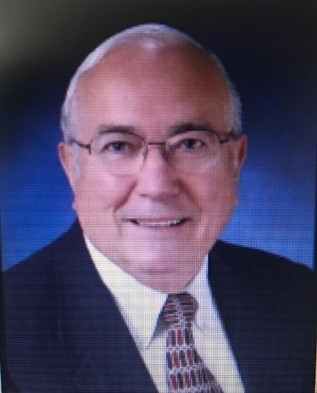 |  | Gale Prince  Upon retiring from an award-winning career in food retailing with The Kroger Co., Mr. Gale Prince has created a second career by helping others around the world in food safety problem-solving, whether consulting or public speaking on food safety. Mr. Prince is a pioneer in the field, dedicating his career to the advancement of the food safety professional, acting as a mentor and inspiration to numerous IAFP Members since joining IAFP in 1968.  As Chair of the IAFP Foundation Mr. Prince brought individual IAFP Members and business partners together with contributions of nearly one million dollars, helping establish the IAFP Student Travel Scholarships, enabling recipients to attend the Annual Meeting, and with sponsorship of IAFP international meetings to address food safety worldwide.  Mr. Prince served as IAFP President in 1998. He is the recipient of the Fellows Award in 2005, the Harry Haverland Citation Award in 2006, the President’s Recognition Award in 2007, the IAFP Honorary Life Membership Award in 2008, and the President’s Lifetime Achievement Award in 2015.
 |  | Dr. Bret Marsh  Dr. Marsh serves as the Indiana State Veterinarian. He is responsible for all statewide animal health programs at the Indiana State Board of Animal Health, as well as providing inspection services for the meat, poultry, and dairy products industries. He has served in leadership positions in the American Veterinary Medical Association, the U.S. Animal Health Association, and the Indiana Veterinary Medical Association. He has received the Distinguished Alumnus Award from both the Purdue College of Veterinary Medicine and the Purdue College of Agriculture. He received his BS degree in Animal Sciences, and his DVM from Purdue University.
 |  | Lori LeMaster  Lori LeMaster began her career as a field EHS in 1995 inspecting food establishments, hotels, public swimming pools, organized camps, and more. Lori also conducted investigations of animal exposures for rabies control. Since 2002, Lori has held various positions within the program including Food Program Trainer, Food Program Manager, Assistant Director, and Director of Environmental Health.  Between 2008 and 2015 she represented the southeastern states on the Executive Board of the Conference for Food Protection and served as conference Chair between 2012- 2014.
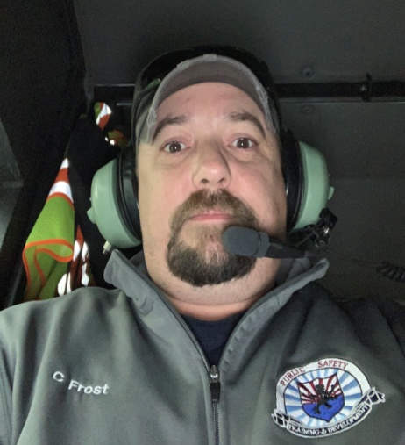 |  | Corey Frost  Corey’s interest in helping people started long ago during his youth spent with the Boy Scouts while growing up all over the world as an Army brat. Life came full circle when he won a grant to start the Brown County Public Safety Training Institute where he serves as the Director.  Now, while working as the Emergency Preparedness Coordinator for the Brown County Health Department and as an EMT, his primary mission is to continue to provide cost effective training and instruction to first responders from across Indiana.  The “Stop the Bleed” curriculum falls right in line with this purpose, and he continues to instruct private industry, educational leaders as well as many other people in various disciplines who are wanting to learn to stop the #1 cause of preventable death after injury; Bleeding.
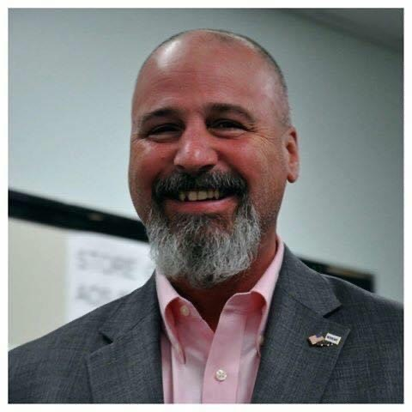 |  | Chris Peasley  Chris Peasley is a thirty-year veteran of the retail food industry. Chris’s retail experience encompasses time as a retail manager for the world’s largest retailer, a small regional organic cooperative and the United States largest grocer. Prior to his retail career, Chris spent six years in the food service industry as a Sous Chef. In February of 2018, Chris was hired by the Georgia Department of Agriculture’s Food Safety Division as their Retail Food Program Manager, a role he holds to this day.  Chris is actively involved with the Association for Food and Drug Officials (AFDO) where he served on the Product Labeling Committee in 2018-2019, the Association for Food and Drug Officials Southern States (AFDOSS), the Georgia Environmental Health Association (GEHA) where is he is an annual featured speaker, as well as serving as the Exhibits Coordinator in 2019-2022, and the Conference for Food Protection (CFP) where he is a voting member and served on the Produce Wash Water Committee in 2018 – 2020.  Chris is directly responsible for ensuring that retail food sales establishments confirm to and are compliant with the Rules of the Georgia Department of Agriculture, all applicable laws, and food safety best practices, through monitoring the safety and wholesomeness of food products sold in the State of Georgia. As the Program Manager, Chris oversees a staff that consists of 3 District Managers, 1 Special Processes Consultant, 3 District Administrators, and 41 Retail Compliance Specialists who are responsible for Food Safety and Food Defense in the retail food industry in Georgia.
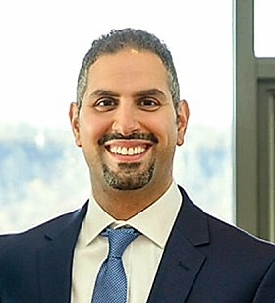 |  | Ramzi Nimry  Ramzi earned his Bachelor of Arts in Communication Studies with a minor in Psychology from IUPUI-Indianapolis. He spent three years with the Indiana Family Social Services, Division of Mental Health and Addiction and almost two years with Regenstrief Institute’s Center for Aging Research focused on Alzheimer and dementia patients. Currently, he is the Trauma and Injury Program Director with the Indiana Department of Health, Division of Trauma and Injury Prevention where he oversees the Indiana Trauma Registry, oversight of regional trauma system development throughout the state and trains coroners on the Indiana Coroner Case Management System (CCMS).
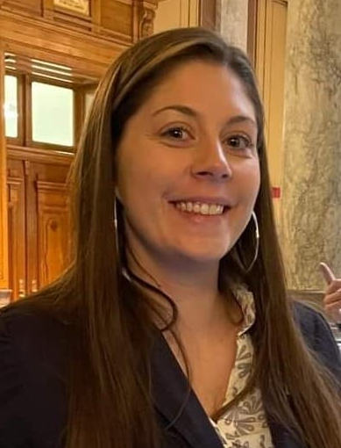 |  | Meagan Cothron  Meagan is a graduate from Ivy Tech Community College with a degree in Human Services. She is a certified Recovery Coach, serving five years in the field of substance abuse and mental health. She started her career as an intern at the Salvation Army Adult Rehabilitation Center in Indianapolis. Her love and passion for recovery and helping others was ignited after witnessing several family members battle their own addiction. She became a certified recovery coach at Centerstone in Seymour, Indiana, making her mark through Southern Indiana. During her time at Centerstone, she had the opportunity to expand the intensive outpatient program and become a part of the Jackson County Drug Court team. She transitioned her role from outpatient treatment to advocacy when pursuing her goal as a freelance journalist focusing on the recovering individuals and the community. Her passion then switched to focusing on prevention work with youth. She is currently serving as a co-founder of a nonprofit organization, Recover Out Loud, utilizing her own experience to empower others in their own recovery journey. She uses her skills and experience for advocacy, prevention, education and raising awareness to empower individuals to recover from the traumas of substance abuse to human trafficking, and every societal issue that impacts our communities.
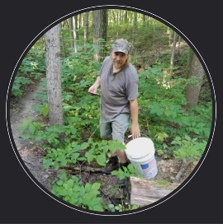 |  | Brian Hunt  Brian has been a forager for wild mushrooms since the 1980’s. He has always had a fascination with the diversity of our surroundings. Lifetime member of the North American Mycological Association, and the Hoosier Mushroom Society. Certified by the Association of Food and Drug Officials (AFDO) and the Produce Safety Alliance (PSA) through Purdue Extension to be a Certified Mushroom Inspector. CEO of Brown County Forest Farming, llc.
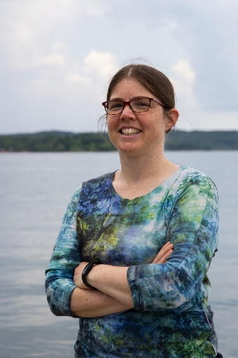 |  | Maggie Sullivan  Maggie Sullivan is an environmental engineer and community organizer. She holds a degree in Agricultural Engineering from Purdue University and has worked for over fifteen years in the fields of environmental consulting, local agriculture, and environmental education. For the past 3 years, Maggie has worked as the Watershed Coordinator for Friends of Lake Monroe, developing a watershed management plan for the lake and planning its implementation
 |  | Dr. Betty Feng  After earning a doctoral degree in Food Science and finishing a 2-year Postdoc program from UC Davis, Betty joined Purdue University in 2018 as an Assistant Professor. Betty’s research program uses a sociological approach to explore human factors that affect food safety behaviors. Her research identifies barriers to understanding food safety risks in kitchens and develops strategies that empower food handlers to make science-based decisions. She authored over 40 peer-reviewed publications and over 70 referred conference proceedings. Her current program has 6 graduate students and 12 undergraduate student researchers. She lives in West Lafayette, Indiana, with her husband, Andy, daughter, Evelyn, and their dog, Cinnamon, and their cat, CreamPuff. They enjoy cooking and love food and food science.
 |  | Clint Studabaker  Mr. Clint Studabaker is a retired Professional Civil/Environmental Engineer. Mr. Studabaker received his B.S. Civil Engineering from Purdue University, an Executive MBA from Northern Illinois University, and a M.A. in Teaching from National Lewis University.  Mr. Studabaker’ s engineering and business career spans the time since the creation of the U.S. EPA until today. Prior to retiring to Brown County in 2015, Mr. Studabaker directed project activity for numerous Fortune 500 clients for projects involving environmental and waste services, lowering environmental liabilities, and resolving wastewater, waste disposal, energy recovery, and groundwater issues. He began his career with the Atchison, Topeka, and Santa Fe Railroad as the emergency responder and environmental engineer for train derailments involving hazardous materials. Mr. Studabaker directed engineering and construction services for a premier international hazardous waste management company. Mr. Studabaker managed a business unit for environmental engineering, consulting, and construction services that served clients throughout North America and around the globe. Throughout his career, projects included remediation of Superfund sites, hazardous waste incinerators, waste landfills, mobile wastewater treatment units and mobile laboratories for groundwater analysis and cleanup, and energy production through landfill gas-to-energy plants. In 2018, Mr. Studabaker was appointed by the Brown County Council to serve on the Brown County Regional Sewer District board of directors.
 |  | Kenneth K. Jones,  Kenneth K. Jones is a Professional Land Surveyor, and the President and CEO of Jones Petrie Rafinski, a medium sized multi-disciplinary consulting firm of over 65 employees. JPR helps plan, design, and build greater infrastructure and improved communities with a variety of architecture, engineering, and planning services. Over the last 30 years, Ken led the firm as it has expanded to provide a wide variety of services to a diverse clientele that includes municipal entities of all sizes, and private clients including industrial and commercial developers.  Mr. Jones has expertise in long-range planning; interlocal partnerships; funding resources; water and wastewater master planning and studies; economic development planning; storm water management planning; right-of-way engineering, acquisition, and surveying; water distribution systems; and wastewater collection systems (gravity, vacuum, and low pressure).  He currently serves as President of the Economic Development Corporation and Brownfields Management Board of St. Joseph County, MI and is a professional affiliate of the American Planning Association and the Indiana Society of Registered Land Surveyors
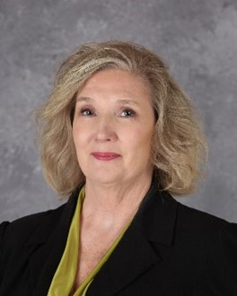 |  | Christine Stinson  Christine Stinson has been a member of the Indiana Environmental Health Association since 2002. Christine is a Past-President of the Association. Currently, Christine is the Executive Director of the Wayne County Health Department in Richmond, IN. Prior to taking the position with Wayne County, she was the Administrator of the Marshall County Health Department. Before taking the position with the Marshall County Health Department, Christine worked with the Indiana Department of Environmental Management in the Office of Drinking Water as a Compliance and Enforcement manager in the Northern Regional Office. While Christine found great satisfaction in working in the Office of Drinking water, her true passion in the field of public health has always and will always be at the Local Health Department Level. This is where she feels she can make the most impact in the lives of the community in which she lives and serves.  Christine Stinson is a proud Graduate of Ball State University in Muncie, IN. Christine also completed her fellowship with the Mid-American Regional Public Health Leadership Institute in 2017 with the University of Illinois at Chicago.
 |  | Darren Meyers  Darren Meyers, P.E. currently oversees the development of controls and embedded systems for the Zoeller Company in Louisville, Kentucky. For thirteen years he served as Zoeller’s Application Engineer and, for a time, also managed the Inside Sales Department. Darren’s background includes design and analysis of wastewater networks, troubleshooting of water treatment systems, and software development for pump sizing and configurators. He holds a degree in Civil Engineering from the University of Dayton and is licensed as a professional engineer in multiple states. In addition to his current role managing the controls effort, he remains involved in developing software tools for the company and its customers and aiding in many aspects of pump system design including decentralized wastewater projects, force main networks, advanced control components, biological processes, treatment methods, and soil dispersal technologies. He has worked with the Zoeller Company since 2004
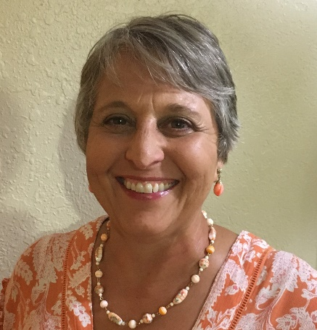 |  | Debbie Barnhizer  In January, Deb Barnhizer celebrated the 31st anniversary of her first day at IDOH!  She’s spent most of her career in the on-site program, where she does her dream job every day.  For nearly 20 years, she worked with local health departments. Her favorite role was training new staff. She learned the most troubleshooting failures, assisting with difficult site design, and surveying systems utilizing technologies new to Indiana.  In 2016, Deb joined the commercial plan review program. What she likes best in her current role is helping designers climb the commercial learning curve and being on a team that continually improves its process because better plans result in better systems
 |  | Dr. Jesse Knibbs  Dr. Jesse Knibbs is an Enteric Epidemiologist at IDOH. She holds a doctorate in veterinary medicine from Purdue University and a master’s in public health from the University of Minnesota. She started her career in public health working for the USDA Food Safety Inspection Service. Dr. Knibbs started working for the IDOH Epidemiology Resource Center as an enteric epidemiologist in February 2022, focusing on food and waterborne outbreaks
 |  | Madi Asbell  Madi Asbell is an Infectious Disease Epidemiologist at IDOH. She earned her master’s in public health from IUPUI in 2020 and has been working for the IDOH Epidemiology Resource Center since 2019. She focuses on Legionnaires’ disease surveillance and outbreak response in Indiana and also assists with many other reportable conditions
 |  | R.J. Beck  R.J. is a graduate of Purdue University and began his career in public health working for Tippecanoe County Health Department as an Environmental Health Specialist for 4 years. During that time he had primary responsibility for mosquito control, swimming pool program, water quality program, and lead based paint inspections.  Upon moving to Southeast Indiana where he currently resides, R.J. continued his career in public health with the Northern Kentucky Health Department where he started his path into food safety for the next 11 years as the Environmental Health Coordinator. As a trained FDA Food Retail Food Safety Specialist, he trained and standardized all food inspectors in accordance to FDA Model Food Code standards. In addition to retail food safety inspections, R.J. managed the Temporary Food Program, Mobile Food Program, and was the proctor for all Food Manager Certification classes.  In 2020, R.J. joined Kroger, where he currently serves as a Corporate Retail Food Safety & Regulatory Compliance Manager based out of the Corporate Office in Cincinnati, OH. In this role, he has oversight of regulatory compliance for over 2500 retail locations ensuring training, food handling policy & practices, and making sure that merchandising programs are designed and executed in alignment with local, state, and federal requirements. He also is responsible for issuing over 350 product recalls annually, ensuring that products are removed from stores and the supply chain in timely manner. R.J. is passionate about creating and maintaining a culture of food safety where we produce and serve safe, wholesome food that our customers want to choose again and again.
 |  | JoAnn Xiong-Mercado  JoAnn has been with the Marion County Public Health Department for 11 years. JoAnn started in Mosquito Control as a seasonal technician in May 2011 and then transferred to Food & Consumer Safety in September 2011. JoAnn has held Secretary, Vice President, and President chairs for the IEHA Central Chapter from 2012-2014, received a Central Chapter Mark Fry award in 2013, was IEHA President in 2017, and currently is a co-chair for the Food Protection Committee. JoAnn has a BSPH from IUPUI and had an internship with the Columbus Public Health Department in Columbus, OH with a special project about rodent control and food safety. She earned an AS in Hospitality from Ivy Tech Community College’s Culinary program in 2014. JoAnn is a Fellow from the International Food Protection Training Institute (IFPTI) Fellowship in Food Protection program in 2016-2017. JoAnn just presented a food track session at the NEHA AEC in Spokane, WA about a training resource called “Ethnic Food Safety Training Toolkit” in June 2022. She is the Special Process Specialist at the MCPHD and her day-to-day consists of field inspections, reviewing HACCP applications that do not require a variance, a trainer for new EHS, and help with projects for the FDA Standardization program.
 |  | Erik Ohannesian  Erik Ohannesian is the Rabies Epidemiologist at the Indiana Department of Health. He graduated from Indiana University in May 2020 with a degree in Environmental Management from the O’Neill School of Public and Environmental Affairs. Before joining IDOH as the Rabies Epidemiologist, he also spent a summer with the agency as a Mosquito Surveillance Intern. He has a long-standing passion for the intersection of human health and the environment
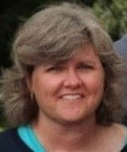 |  | Krista Click  Krista Click is the Health Department Administrator for the Hendricks County Health Department and Vice President of the Indiana Environmental Health Association. Working in public health since 2000, she previously served as the Food Protection Program Director and Manufactured Food Regulatory Program Standards Project Coordinator for the Indiana State Department of Health and the Foods Team Leader and Environmental Health Specialist for the Hendricks County Health Department. Krista has earned her Bachelor of Science degree in Public Health from Indiana University – Purdue University Indianapolis and her Master of Science in Management degree from Indiana Wesleyan University
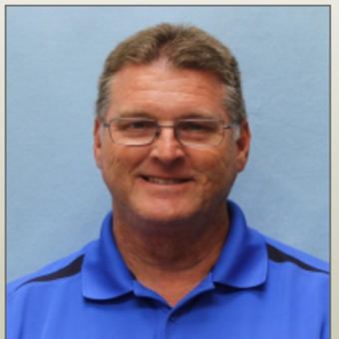 |  | Jeffrey Corder  Jeffrey Corder retired from the Brownsburg Fire Territory after 26 years of service in 2017. He held all roles from Lieutenant to Assistant Chief and retired as a Captain. Jeffrey has also been an Indiana Licensed Paramedic for 35 years. He has a Bachelor’s degree from IUPUI in Public Administration and a Master’s Degree in Emergency Management from Columbia Southern University. Jeffrey has been the Public Health Preparedness Coordinator for Hendricks County for 5 years and also coordinates the Hendricks County Medical Reserve Corps. Jeffrey is married with 1 grown son.
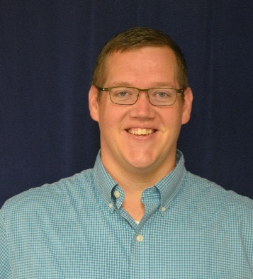 |  | Paul Krievins  Since November of 2017, Paul has served as the Division Director for Lead and Healthy Homes with the Indiana State Department of Health. Paul has spent more than a decade in public service working to create transparency, accountability, and data-driven solutions in the health and energy affordability sectors. Most recently, Paul has spent time working with ISDH on COVID-19 response and on IDOH’s efforts to increase testing for, and accountability around, children with elevated blood lead levels. In his free time, Paul enjoys traveling with his wife, volunteering, and working on his 1910-era home.
 |  | Diana Foster  Diana Foster graduated from IUPUI with a BA in Criminal Justice in 2012. She has worked for Adult and Child Health for 14 years. She has served in a variety of roles, including as an Office Coordinator, a Care Coordinator, a Billing Specialist, and a Clinical Excellence Specialist. Diana’s current role is Safety Officer and Disaster Response Team Leader. Diana’s work has helped advance the mission of safety and emergency preparedness in the state of Indiana. Diana currently leads the mental health subcommittee for the District 5 Healthcare Coalition. Diana also is the Indiana mental health representative on the FEMA Region 5 Pediatric Disaster Response Team. This national coalition is working to build curriculum to be taught to emergency department residents on responding to pediatrics with developmental issues during a disaster. Furthermore, Diana sits on the District 5 Resilience and Emotional Support Team (REST) who provide Psychological First Aid (PFA) and Crisis Incident Stress Management (CISM) to those who experience trauma in disasters.
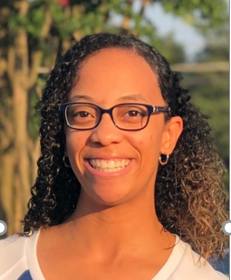 |  | Mariah Allen  With nearly 10 years in the Food Industry, Mariah Allen holds experience in Retail, Food Service, and Government Affairs. Her experiences include employment at Stone Mountain Park as a Food Safety Trainer, Assistant Manager for Bojangles™, Sanitarian for the Georgia Department of Agriculture (Retail Division), and currently at Meijer™ as a Regional Food Safety Specialist.  Mariah is a 2015 graduate of Jacksonville State University (B.A Biology) and a 2019 graduate of the University of Maryland-Global Campus (M.S Environmental Management).  Between 2016-2019, Mariah was employed with the Georgia Department of Agriculture as a Retail Sanitarian where she conducted retail inspections for 600 establishments within her span of care in the Metro Atlanta area. In addition to routine inspections, Mariah conducted COOL audits in partnership with the USDA at select facilities. In 2018, she obtained her FDA Retail Standardization certificate, standardizing her to the 2017 retail food code.  Currently, Mariah supports 54 Meijer and Fresh Thyme locations ensuring sanitation, regulatory compliance, and quality assurance throughout Indiana and Kentucky.  Mariah resides in Central Indiana and enjoys traveling in her spare time, while editing Vlogs dedicated to her Travel experiences.
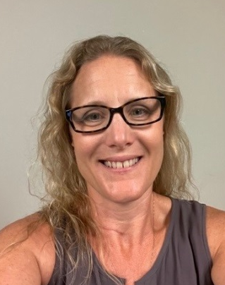 |  | Faith Freed  Faith Freed, MPH is the Administrator and Chief Environmentalist of the Marshall County Health Department. She started her public health career at the LaPorte County Health Department in 2015. In 2018 she accepted a position at the Marshall County Health Department and has since received a bachelor’s degree in Environmental Management and a Master’s in Public Health from Columbia Southern University. She has recently been married and between them have 6 kids and one adorable granddaughter
 |  | Gretchen Quirk  Gretchen Quirk has worked at the Marion County Public Health Department for 23 years and manages the Body Art Program
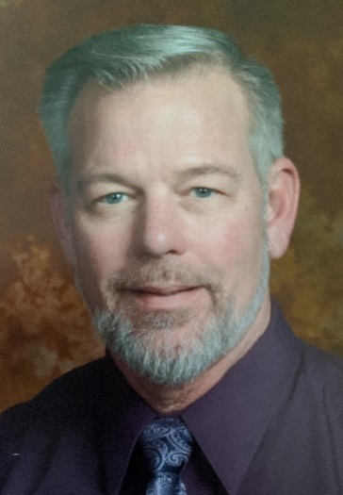 |  | Doug Wagner  Doug Wagner CFM, is the Senior Water Planner for Indiana Department of Natural Resources, Division of Water’s Floodplain Management Section.  Doug received a B.S. from Purdue University in Building Construction and Contracting. As part of this degree program, he completed one year of land surveying while at Purdue. He has been involved in the construction industry for over 30 years with his primary focus being on residential and light commercial structures. Doug began his career with an industrial contractor and later started his own company as a custom home builder which he operated full time until 2006. Today he still engages in some smaller remodeling projects in his spare time. He worked as a local building inspector, floodplain administrator, and zoning administrator since January 2014. He completed the L273 Managing Floodplain Development Through the National Flood Insurance Program in August 2014 and earned his Certified Floodplain Manager certificate in September 2014. Doug joined the Department of Natural Resources in November of 2018. In his current role his primary duties are education and outreach across the state with floodplain management and the National Flood Insurance Program. In this role he prepares, schedules and hosts workshops and conferences, he also serves as editor of the Division’s “Waterlines” a quarterly newsletter. He has also successfully completed the Emergency Management Institute’s Elevation Certificate (EC) and Substantial Damage Estimator (SDE) self-study courses.
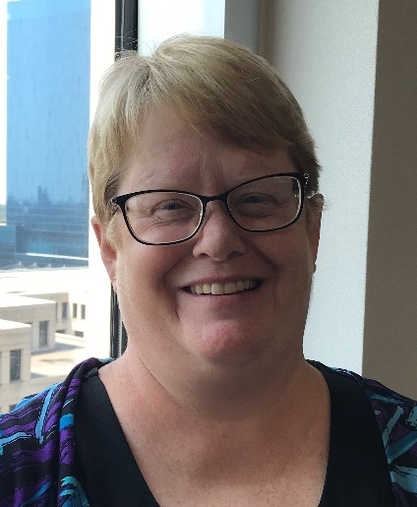 |  | Alice Quinn  Alice Quinn is a lifelong resident of Grant County and a graduate of Purdue University. She also studied Agriculture at the University of Newcastle Upon Tyne, in Newcastle, England in her junior year. Alice previously managed a large farrow-to-finish hog operation but began her public health career at the Grant County Health Department in 1998 in the Environmental Division. She later became the supervisor of that division. In 2010, Alice joined the Environmental Public Health (EPH) Division of the Indiana State Department of Health as a regional field staffer for northeast Indiana. In 2015, Alice moved to the Commercial Plan Review Division in the EPH Division where she worked with commercial system designers and conducted plan reviews of commercial on-site systems. In 2016, Alice took the position of Manager for the IDOH Residential On-site Sewage System Program. Alice is a past board member and a past president of the Indiana Onsite Wastewater Professional Association and currently is the Co-Chair of the Indiana Environmental Health Association’s Wastewater Management Committee. She is also involved with the State Onsite Regulator’s Association and the National Onsite Wastewater Recycling Association.
 |  | Mike Martin  Mike Martin is the Corporate Trainer of pre-engineered fire suppression systems for Koorsen Fire and Security. Mike started in the fire safety industry in 1989 after graduating from Vincennes University in 1988. Mike began as a fire extinguisher tech, and then started installing and servicing pre-engineered fire suppression systems in 2000.  Mikes past experience included Operations Manager and Zamboni Driver for the Indiana World Skating Academy from 1989-1998.
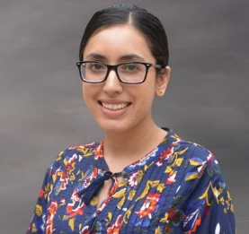 |  | Sandeep K. Bains  Sandeep Bains is the Chief Nurse Consultant for the Epidemiology Resource Center at the Indiana Department of Health
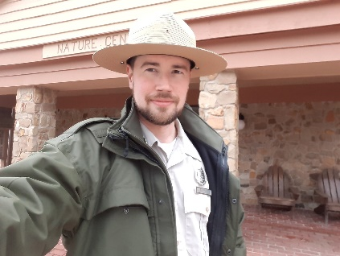 |  | Eli Major  Eli Major is the interpretive naturalist at Brown County State Park. He joined Indiana State Parks in 2018, with experience at Spring Mill, Turkey Run, and Shades State Parks before Brown County. Nature and reforestation is a lifelong passion, beginning during his childhood when his family lived on their tree farm. Eli is a 2010 graduate of Indiana University, and a 2015 graduate of the University of Wyoming’s Master of Public Administration and Natural Resource Management program.
 |  | Tom Wallace  Mr. Wallace is an environmental engineer with 30+ years in aviation, industrial and production operations: permitting, Title V environmental emissions data collections and inventories, health risk assessments, mitigation and clean-up operations. He was environmental engineer on the B-1B Strategic Bomber and other Programs with Rockwell International at Air Force Plant 42 and Edwards AFB, and a member of the Rockwell Corporate Environmental Council. He has worked on projects at Rocketdyne Santa Susana Field Lab, Northrup, McDonnel Douglas, 3M, ARCO, General Motors, and Wright Patterson AFB.  In 2016 he founded the Martinsville, Indiana Superfund site Association (MISSA), an Indiana non-profit organization, as a community engagement and educational vehicle in response to the contaminated groundwater in Martinsville and vapor intrusion health concerns. In 2019 MISSA entered a partnership with Dr. Sa Liu, Purdue Environmental Health Studies. The partnership is currently engaged in 4 environmental health studies in Martinsville funded by Showalter Foundation, Robert Woods Johnson Foundation, and NIH.  He is a member of the EPA Community Advisory Group: Martinsville Superfund Remediation, Director Community Action Board (CAB) Purdue environmental studies in Martinsville, Co-Investigator Purdue/Showalter Foundation study: Tetrachloroethylene (PCE) contamination and Children’s Health, Co-Investigator Purdue/NIH Study: Tetrachloroethylene Exposure in an Impacted Community: Residents' Concerns, Neurotoxic Effects, and Exposure Reduction, Senior Advisor Purdue/RWJ study: Groundwater Contamination and Health /Equity in a Midwest Community.  Other activities: Trustee: Scottish Society, Co-Captain of the Scottish Highland Games; Trustee: Nationalities Council of Indiana; MENSA and Phi Theta Kappa. He is former Chairman of the Morgan County Democratic Party and ran for Mayor of Martinsville and for Indiana Senate, District 37. He is currently running for Morgan County Commissioner. His family has been in Indiana for over 200 years and the earliest European branch arrived in North American in 1607.
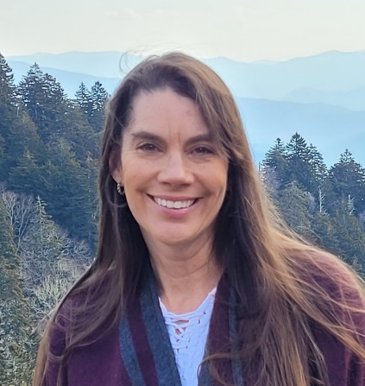 |  | Dena Anderson  Dena has been a soil scientist for nearly 31 years. She graduated Morehead State University and has worked the majority of her career in Indiana and Kentucky. She was a soil survey project member and leader working on the update of soil surveys in Indiana and a quality assurance specialist for soil survey in Kentucky/Tennessee. Most recently as a resource soil scientist she is responsible for providing soils information for a variety of USDA projects, training and assisting agency and the public with the uses of soils information. Dena is also a member of a national instructor cadre teaching agency staff wetland identification and delineation. In addition to her “day job,” Dena is the owner of Glacier’s Edge Soil Consulting. The majority of this work is assisting homeowners in the evaluation of potential septic sites on their projects. In her spare time she enjoys hunting, fishing, gardening and going to car shows with her and her husband’s 1986 Buick Grand National.
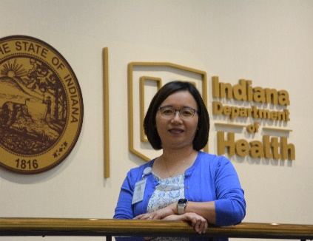 |  | Vivian McCurdy  Vivien McCurdy is the Director for the Food Protection Division at Indiana Department of Health. As a trained Registered Dietitian, she worked as a Dietary Manager in multiple nursing homes facilities, Director for Food Safety and Nutrition in a Community College, and as the Supervisor for the Indiana Produce Safety Program. Vivien obtained her master’s in public administration from Western Michigan University, and a Certificate in Global Food Issues from Michigan State University College of Law. Vivien loves anything related to food and is a big supporter for the farm-to-?”?table local food movement. She is a gardener and a landscape art quilter
 |  | Jordan Young  Jordan Young started his career with IDOH – FPD In February of 2015 where he worked as a wholesale inspector for six years conducting manufactured foods inspections, consultations, and sampling. Jordan took over as the program supervisor in March of 2021, but Ieft shortly after to join AIB International, Inc. as a Food Safety Professional where he conducted food safety audits, training audits, and regulatory preparedness audits. Jordan recently rejoined the IDOH team in June of 2022 as the Manufactured Foods Program Manager.”

